Solar Request for Proposal Attachment A

Site Information
Civic Center – 200 S Illinois Ave, Carbondale, IL 62902
Average Monthly Energy Use: 63,326 kWh
Average Monthly On Peak Demand: 174 kW

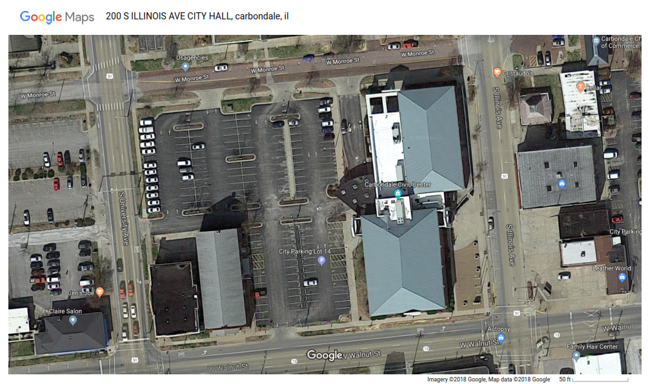

24 Months of Usage and Demand History (Embedded PDF, double-click to open)
Site Contacts
Sean Henry
City of Carbondale
Public Works Director
shenry@explorecarbondale.com
(618) 457-3270
Robert Hardin
City of Carbondale
Maintenance & Environmental Services Manager
rhardin@explorecarbondale.com
618-457-3273
Public Safety Center – 501 S Washington St, Carbondale, IL 62901
Average Monthly Energy Use: 41,480 kWh
Average Monthly On Peak Demand: 97 kW

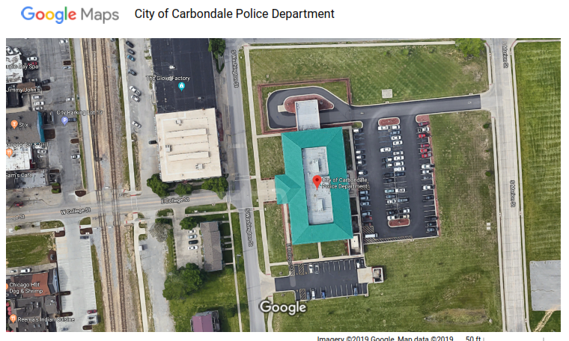

24 Months of Usage and Demand History (Embedded PDF, double-click to open)
Site Contacts
Sean Henry
City of Carbondale
Public Works Director
shenry@explorecarbondale.com
(618) 457-3270
Robert Hardin
City of Carbondale
Maintenance & Environmental Services Manager
rhardin@explorecarbondale.com
618-457-3273

SE Waste Water Treatment Plant – 2201 East Walnut Street, Carbondale, IL 62091
Average Monthly Energy Use: 132,732 kWh
Average Monthly On Peak Demand: 324 kW

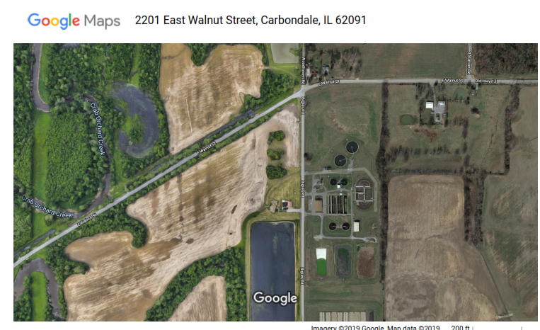

24 Months of Usage and Demand History (Embedded PDF, double-click to open)
Site Contacts
Sean Henry
City of Carbondale
Public Works Director
shenry@explorecarbondale.com
(618) 457-3270
Robert Hardin
City of Carbondale
Maintenance & Environmental Services Manager
rhardin@explorecarbondale.com
618-457-3273
Maintenance/Environmental Services – 212 West Willow Street, Carbondale, IL 62901
Average Monthly Energy Use: 1,050 kWh
Average Monthly On Peak Demand: N/A

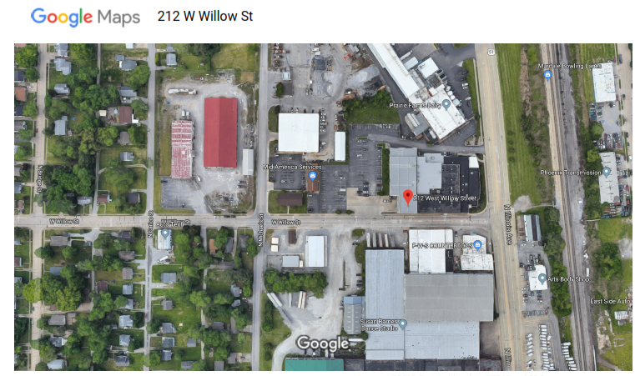

24 Months of Usage and Demand History (Embedded PDF, double-click to open)
Site Contacts
Sean Henry
City of Carbondale
Public Works Director
shenry@explorecarbondale.com
(618) 457-3270
Robert Hardin
City of Carbondale
Maintenance & Environmental Services Manager
rhardin@explorecarbondale.com
618-457-3273

PVWatts Inputs
PVWatts is an online calculator for solar generation estimates. Provide energy generation estimates calculated with PVWatts with the proposal. PVWatts is available at:

http://pvwatts.nrel.gov/pvwatts.php

Use the following inputs or provide justification for alternate inputs.

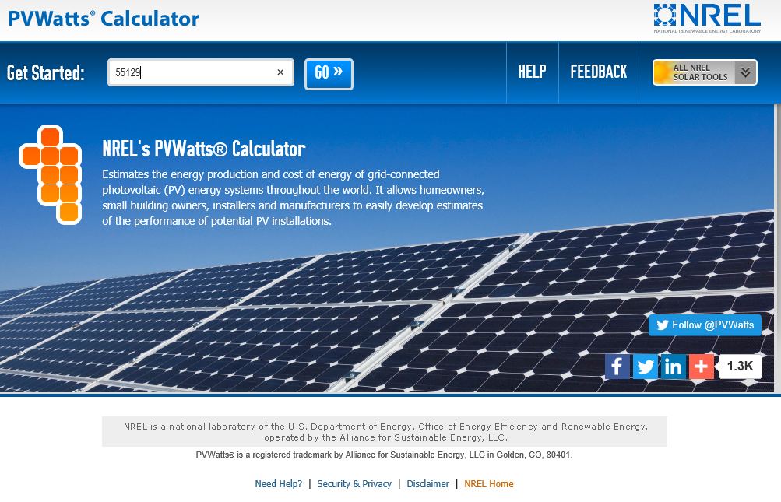
Figure 1:PVWatts Opening Screen

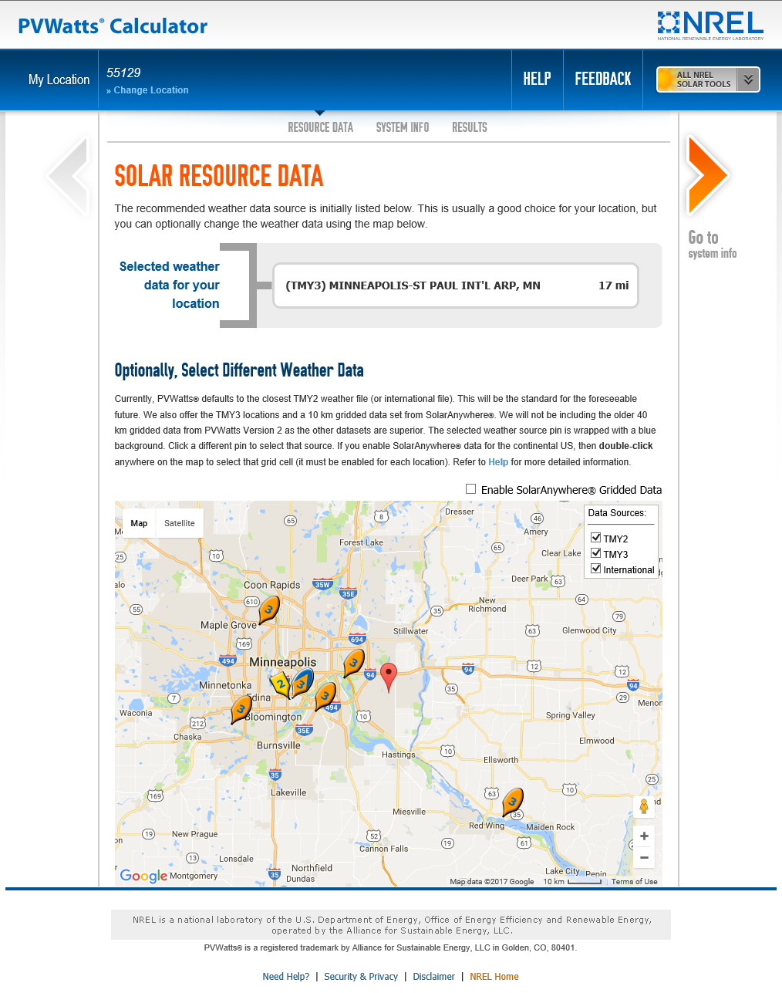
Figure 2: PVWatts Weather Data File Selection
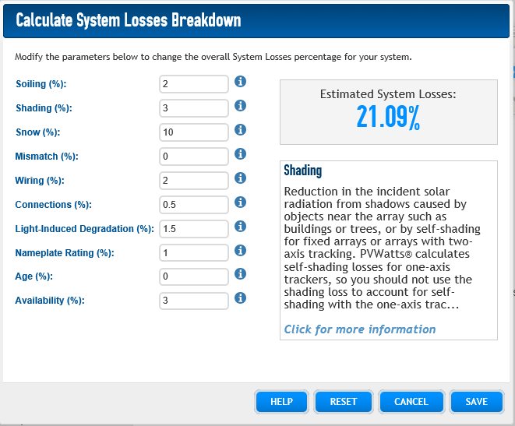

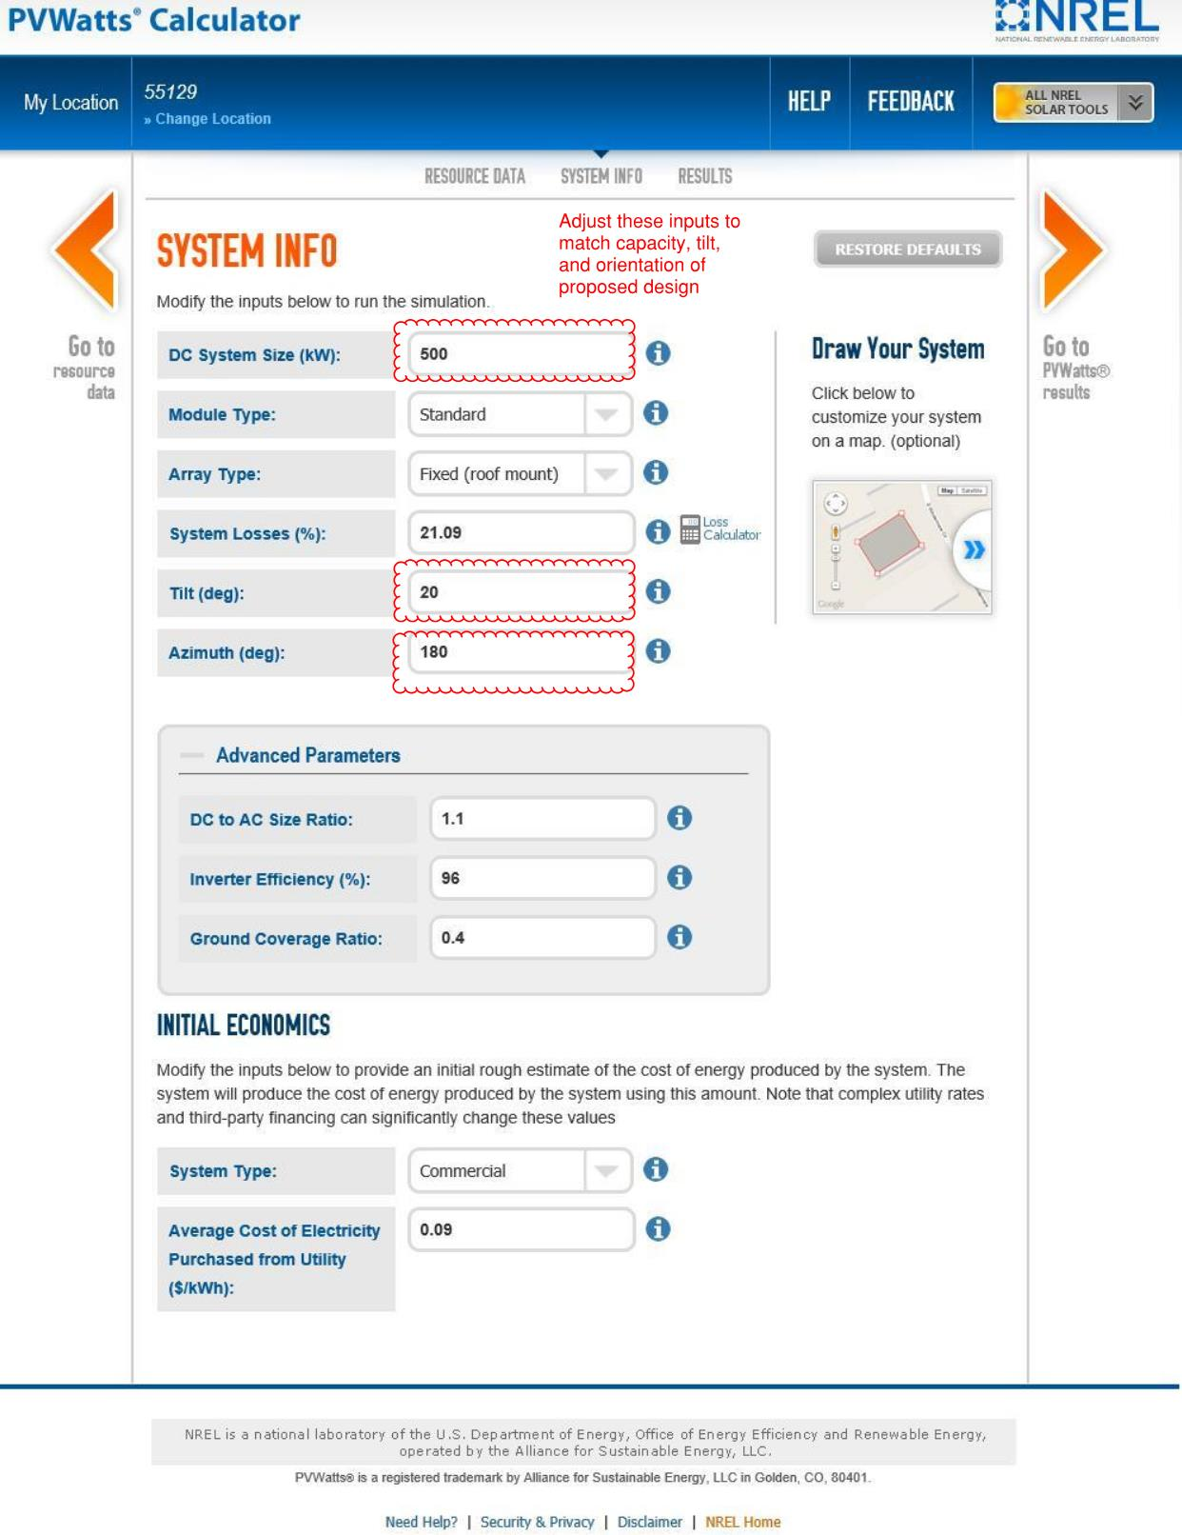
In order to get an estimated system size in DC, multiply your maximum monthly kw demand from Figure 3 (which is in AC) by 1.3.

Energy Generation Estimates
For each array, provide monthly anticipated kWh generation as shown in Figure 6.

In addition, review the hourly outputs to provide the maximum annual hourly generation (peak kW).

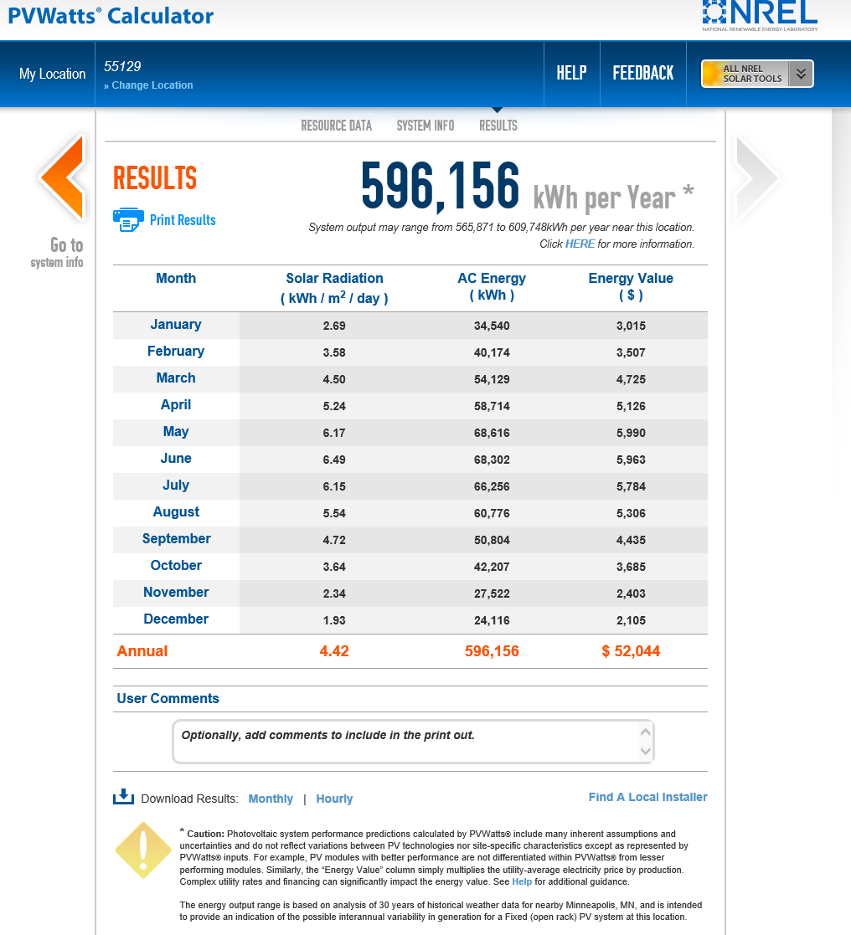
Figure 3: Generation Estimate for 500kW South Facing Array with 20 Degree Tilt

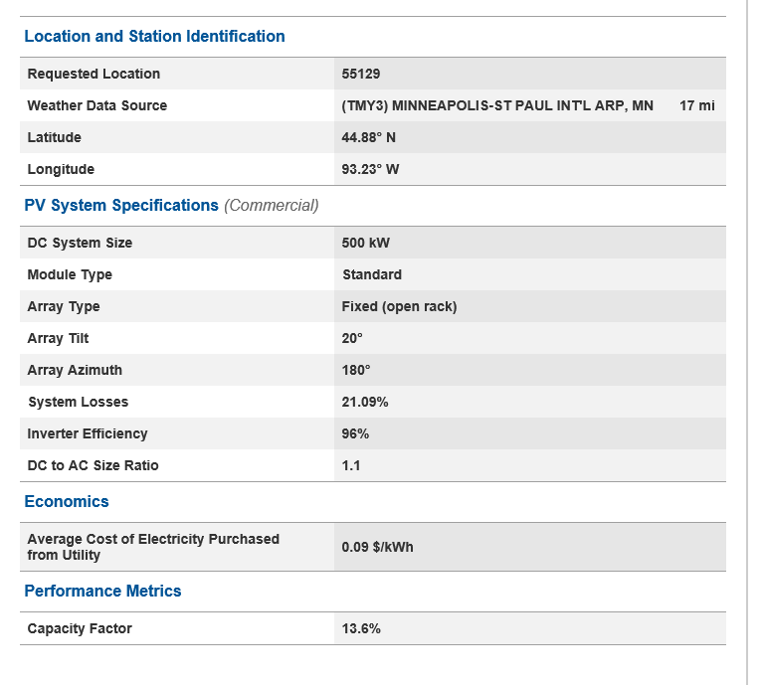
Figure 4: Input Summary for 500kW South Facing Array with 20 Degree Tilt

From the hourly output, the maximum hourly generation level in this example is 399.7 kW

